Street Smart for ArcMap User Manual

Version EN160212

Date: 5 June 2020

# Index

Index 2

1. Installation 3

2. How to use Street Smart for ArcMap 9

2.1 Exploring and viewing Cycloramas in ArcMap 9

2.1.1 How to show recent recording locations of Cycloramas 9

2.1.2 How to configure the Cyclorama viewers 9

2.1.3 How to open Cycloramas 10

2.1.4 How to open historical recording locations 11

2.2 How to show vector data in Cycloramas 12

2.3 Performing measurements 14

2.3.1 Measure Smart measurement – point measurement 14

2.3.2 Measure Smart measurement – line / surface measurement 15

2.3.3 Forward Intersection measurement – point measurement 16

2.3.4 Forward Intersection measurement – line / surface measurement 18

2.3.5 Smart Click measurement – point measurement 20

2.3.6 Smart Click measurement – line / surface measurement 21

2.3.7 How to import a measurement in a Cyclorama 22

2.3.8 How to do a measurement without saving in a layer 24

2.4 Cyclorama search functionality 24

# Installation

To install Street Smart for ArcMap, please perform the following steps:

1. Street Smart for ArcMap can be installed from a disk or network location:
   1. Copy the Add-In file to a (local) disk or network location.
   2. Start ArcMap.
   3. Select menu: *Customize* ► *Add-In Manager* and select the *Options* tab.

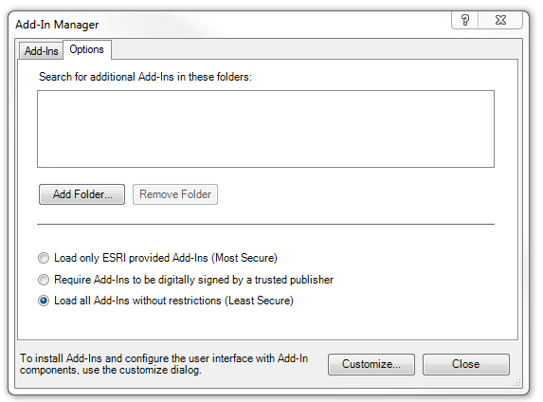

*Add-In Manager, Options tab*.

* 1. Click <*Add Folder...*>. Browse to the folder were the Add-In file is located and click <*OK*>.  
       
      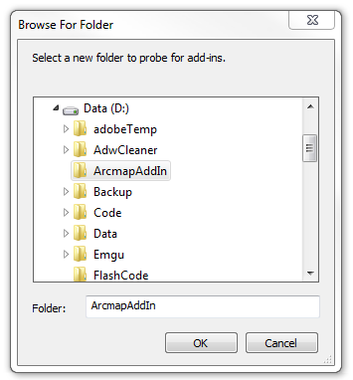

*Browse to the folder where the Add-In file is located.*

* 1. Close the Add-In Manager and restart ArcMap.
  2. Select menu: *Customize* ► *Add-In Manager*.
  3. Check whether Street Smart for ArcMap is ‘*Authenticated’*. If the Add-In is ‘*Untrusted’*, close the Add-In Manager, close ArcMap and install the certificate ‘thawte-intermediate-ca.cer’ first (which is made available together with this user manual).

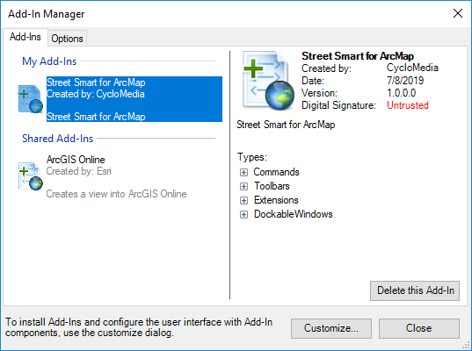

*Add-In Manager, Add-Ins tab, check if Street Smart for ArcMap is ‘Authenticated’ or ‘Untrusted’.*

* 1. To install the certificate, please perform the following steps:
     1. Double-click on ‘thawte-intermediate-ca.cer’ to install the certificate.  
          
         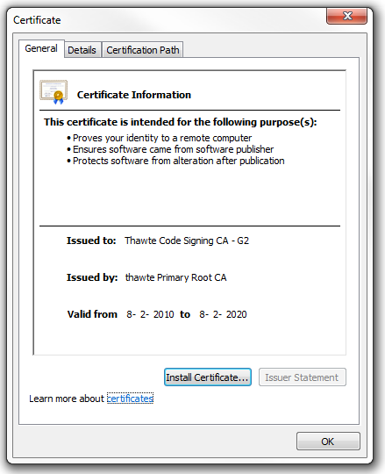

*Install the certificate.*

* + 1. Click on <*Install Certificate...*> to start the installation wizard for the certificate.   
         
       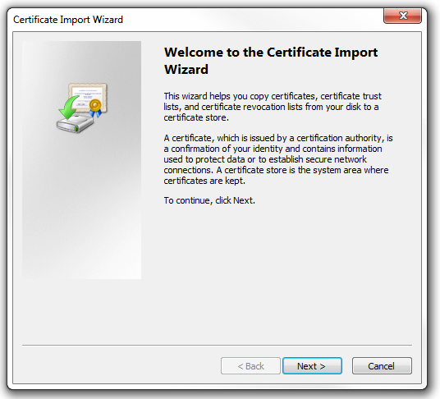

*Certificate Import Wizard.*

* + 1. Click: <*Next*>, <*Next*>, <*Finished*> to complete the installation of the certificate.  
         
        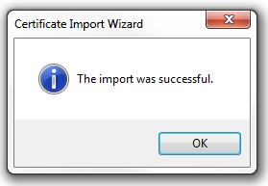

*The certificate is successfully imported.*

* 1. Start ArcMap.
  2. Select menu: *Customize* ► *Add-In Manager*.
  3. Check if Street Smart for ArcMap is now ‘Authenticated’. You can then proceed to paragraph 2).   
       
     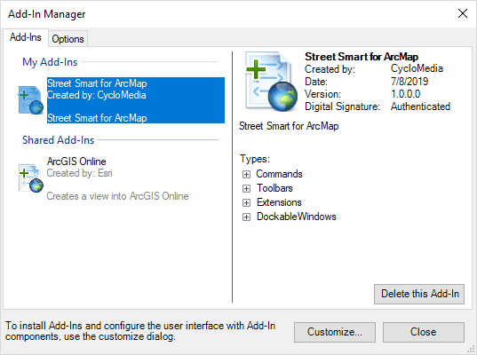

*Add-In Manager, Add-Ins tab, check that Street Smart for ArcMap is now ‘Authenticated’.*

1. If you start ArcMap for the first time after installing the Add-In, you will be shown the agreement form. Mark ‘*I have read and agree to the terms of use*’ as checked and click <*OK*>.  
   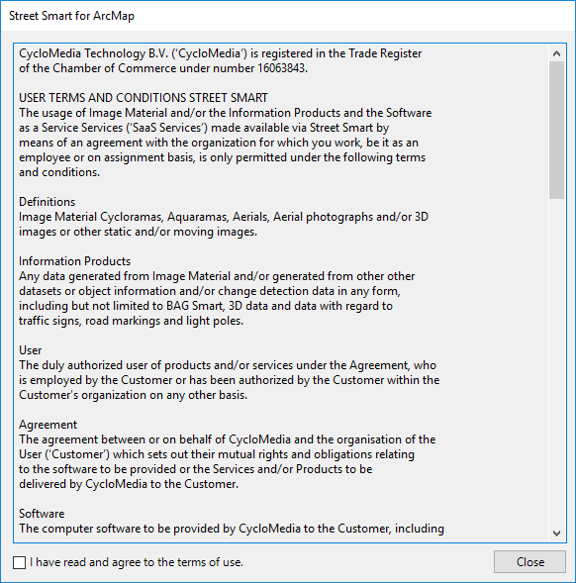

*Agreement form.*

1. If you do not get the agreement form, select menu: *Customize* ► *Extensions*.
2. Mark the extension *Street Smart for ArcMap* as checked. You will now get the agreement form (you will get this agreement form only once). Agree to the terms of use and click <*OK*>.  
     
   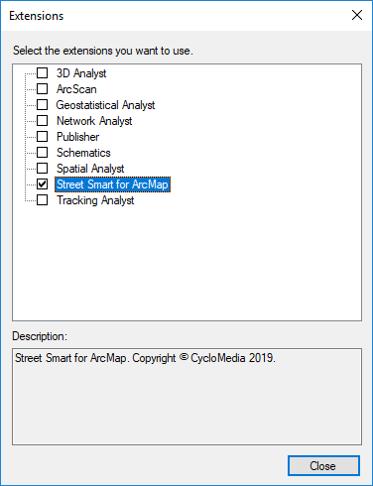

*Extensions window, select the extension Street Smart for ArcMap.*

1. Close the extensions window.
2. Open the Street Smart toolbar: *Customize* ► *Toolbars* ► *Street Smart*.
3. Select the *Street Smart for ArcMap* icon of the Cyclorama toolbar. You will now open the window *Street Smart for ArcMap*.   
   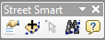  
     
   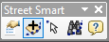

*Street Smart toolbar.*

*The selected Street Smart for ArcMap icon.*

1. Select the tab *Configuration*.
2. If you use a proxy server, you can enable *Use a proxy server* and enter the data about your proxy server.  
     
    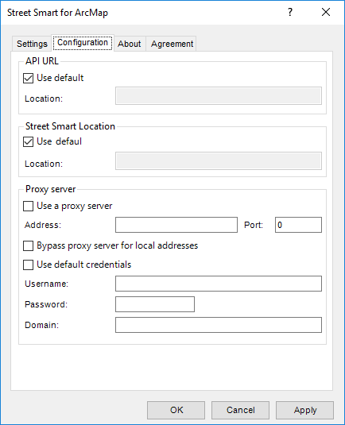

*Street Smart for ArcMap Add-In window, Configuration tab.*

1. If you are using a local installation, uncheck the API URL and the Street Smart location *Use default* option and enter the correct URLs at *Location* instead.
2. Select the *Settings* tab.
3. Enter your username and password and press: <*Test connection*>. If you see the message ‘*Login Successfully*’, you are ready to use Street Smart for ArcMap.   
     
   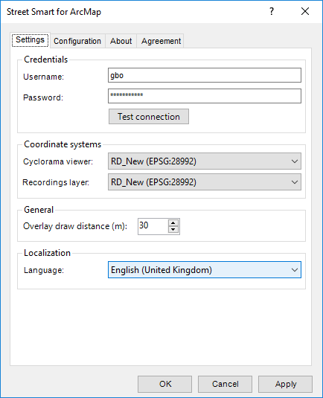

*Street Smart for ArcMap Add-In window, Login tab.*

# How to use Street Smart for ArcMap

## Exploring and viewing Cycloramas in ArcMap

### How to show recent recording locations of Cycloramas

1. Select *Add Recent Cyclorama Layer* in the Street Smart toolbar.   
     
   

*The selected Add Recent Cyclorama Layer icon.*

1. In the *Table Of Contents* of ArcMap a new layer will appear as shown in the figure below. Zoom in on the map to a zoom level of at least 1:2000 to see the recording locations on the map (provided there are recordings in the area).  
     
    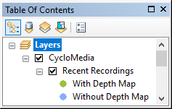

*The layer with recent recordings in the Table Of Contents.*

### How to configure the Cyclorama viewers

1. Select the *Settings* tab of the *Street Smart for ArcMap* window.   
     
   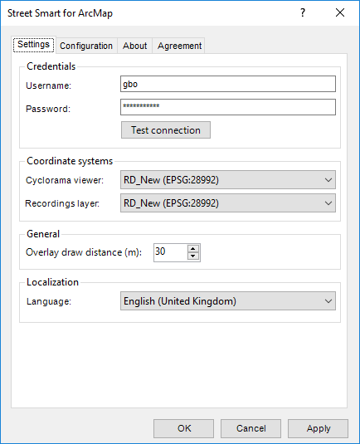

*Cyclorama viewing settings in the Street Smart for ArcMap window.*

1. Select the coordinate system which the viewer(s) should use.
2. Select the coordinate system which the recordings layer should use.
3. Press <*Apply*> for the changes to take effect.

### How to open Cycloramas

1. Select the *Open Location Tool* in the Street Smart toolbar.   
   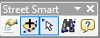

*The selected Open Location Tool icon*.

1. Click on a dot for the corresponding Cyclorama to open in a Cyclorama viewer. Shift-Click on another dot and a second Cyclorama will open.   
     
   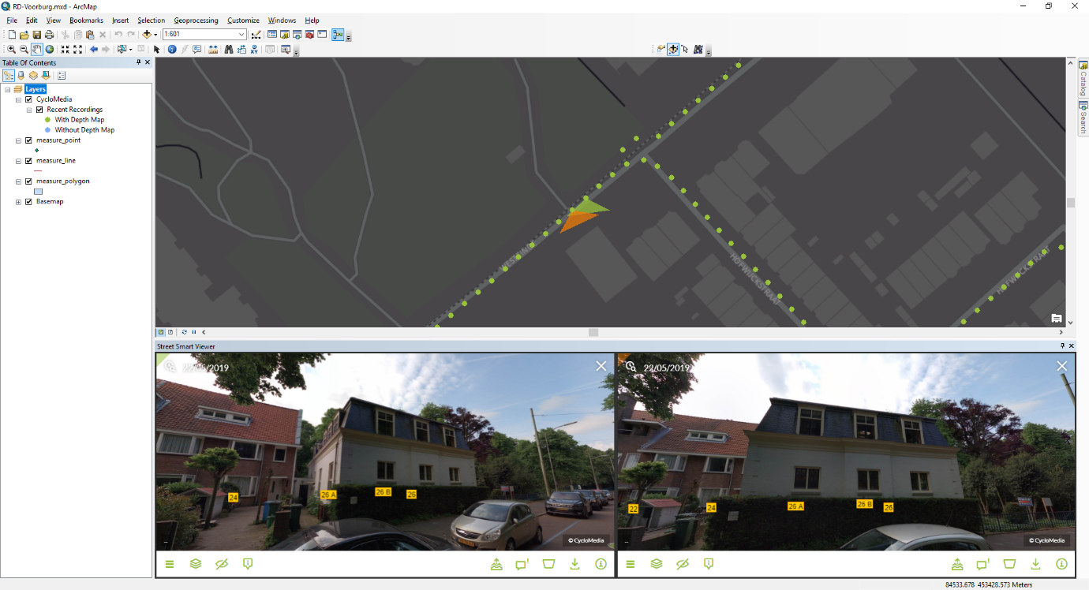

*Street Smart for ArcMap with two Cyclorama viewers opened.*

### How to open historical recording locations

1. Click on the historical Cyclorama slider in the Cyclorama. Select an older image. See the image below.

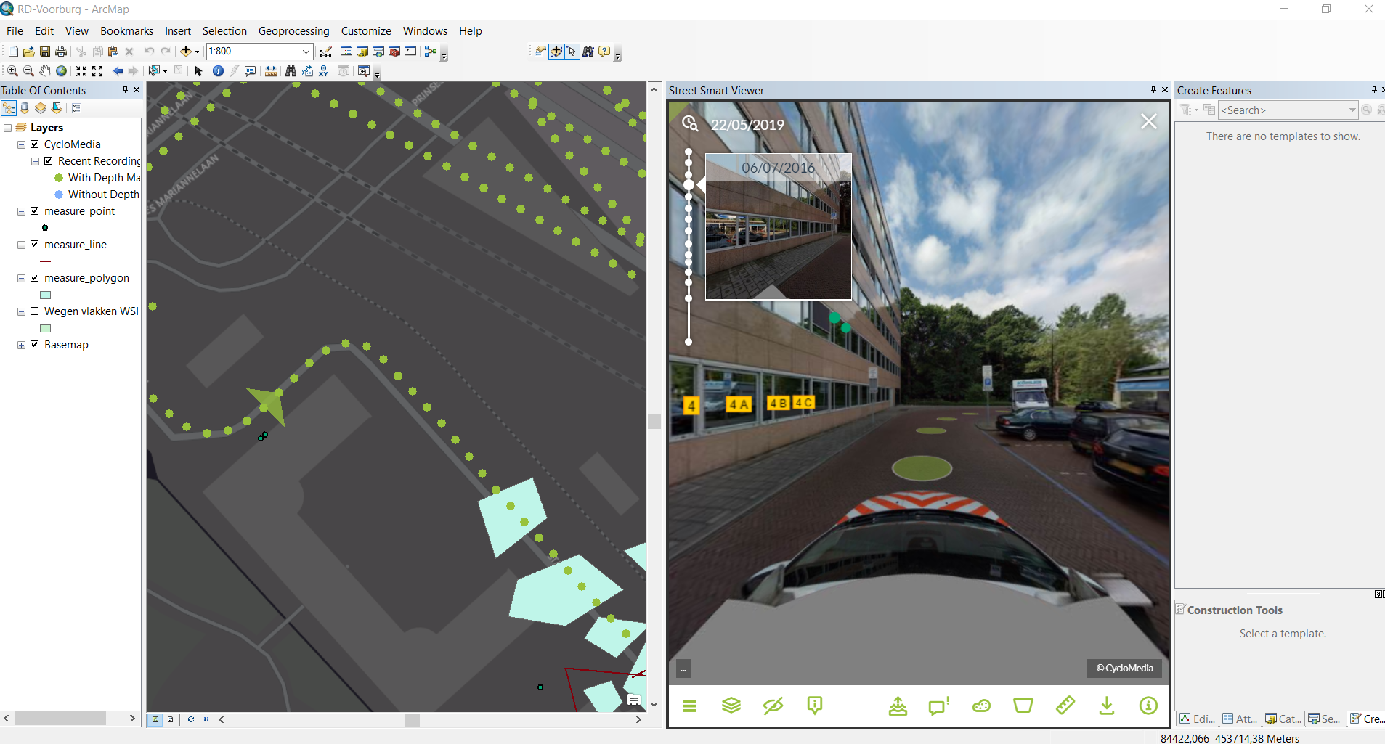

*Cyclorama with an open historical cyclorama Slider*

1. After a historical image has been selected, the recording locations of that year are visible. See the image below.

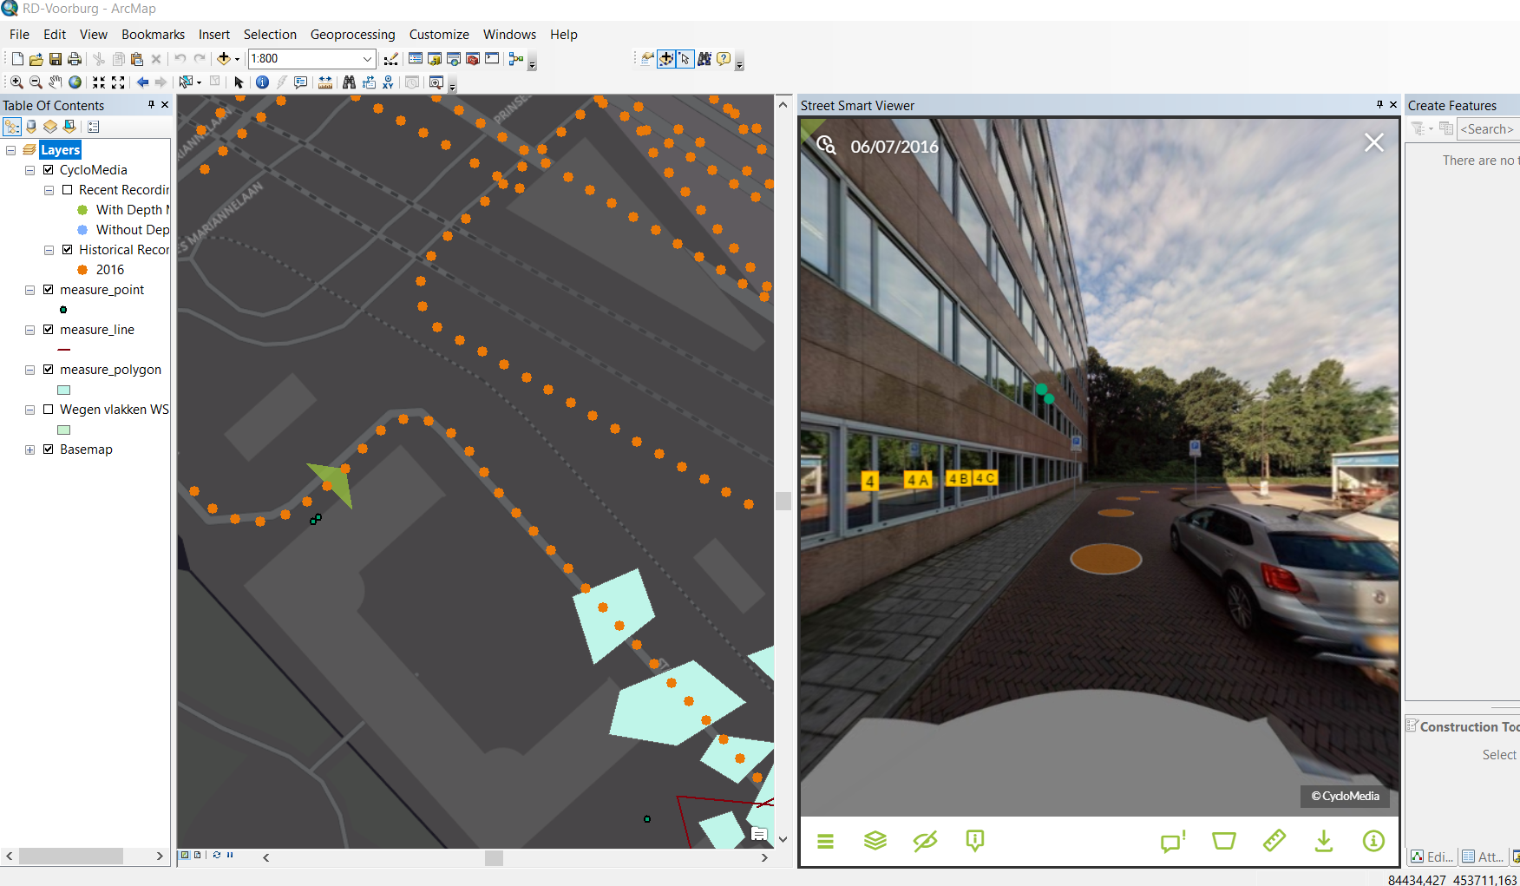

*Map with historical recordings*

1. Now other recordings can be clicked. Those recordings are then opened.

## How to show vector data in Cycloramas

1. Add one of the various types of vector data to the Table Of Contents, such as:
   * Shapefiles
   * ArcSDE
   * Personal MDB
   * File GDB
2. Open a Cyclorama. Note that the vector data will now be shown in the Cycloramas.  
   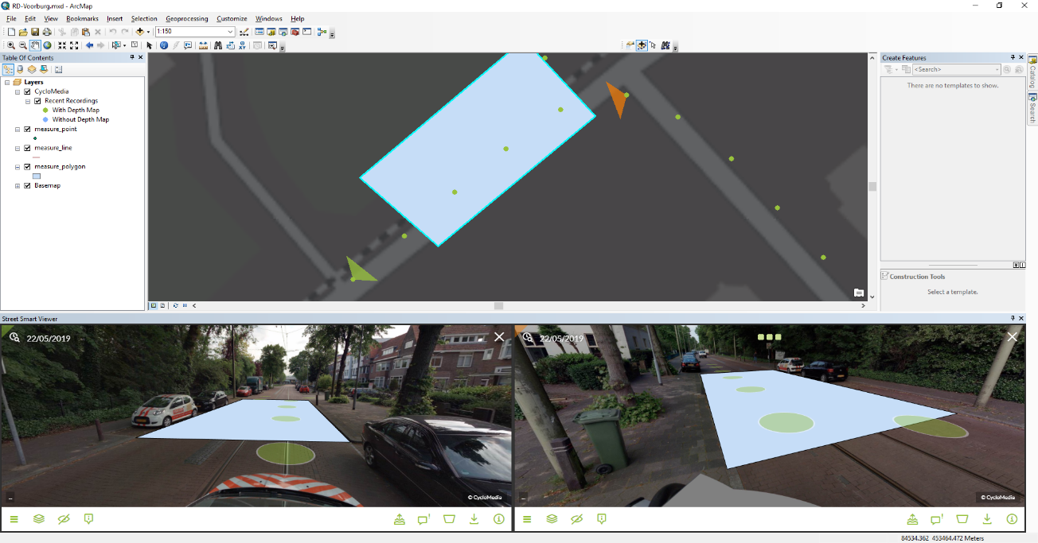

*Showing vector data as overlay in the Cyclorama viewers.*

1. Optionally, set the distance at which vector layer data is displayed in the *Settings* tab of the *Street Smart for ArcMap* window with the option *Overlay draw distance[m]*. The default distance is 30 meters, which means only vector data located within 30 meters of the recording location will be displayed.

## Performing measurements

Measurements are stored in vector data layers. Point, line or surface measurements each are stored in separate point, line or polygon vector data layers. The following sections explain in detail how to perform the various types of measurements. To illustrate the principle of measuring, this manual will guide you through the process of performing Forward Intersection measurements first, before explaining measuring with Smart Click and Measure Smart (default when recordings with depth are available).

* + *2.3.1 Measure Smart measurement – point measurement*
  + *2.3.2 Measure Smart measurement – line / surface measurement*
  + *2.3.3 Forward Intersection measurement – point measurement*
  + *2.3.4 Forward Intersection measurement – line / surface measurement*
  + *2.3.5 Smart Click measurement – point measurement*
  + *2.3.6 Smart Click measurement – line / surface measurement*
  + *2.3.7 How to import a measurement in a Cyclorama*

### Measure Smart measurement – point measurement

1. Add a point vector data layer to the map to store the measurement(s).
2. Open a Cyclorama in which the object to be measured is clearly visible.
3. Right-click on the vector layer and select: *Edit Features* ► *Start Editing* to start editing mode in ArcMap.
4. Select the point vector layer in the *Create Features* window to start a point measurement.
5. Enable Measure Smart measurements in the *Street Smart for ArcMap* window.  
     
   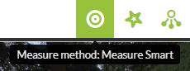

*Enable Smart Click measurements.*

1. Select the point you want to measure in the Cyclorama.

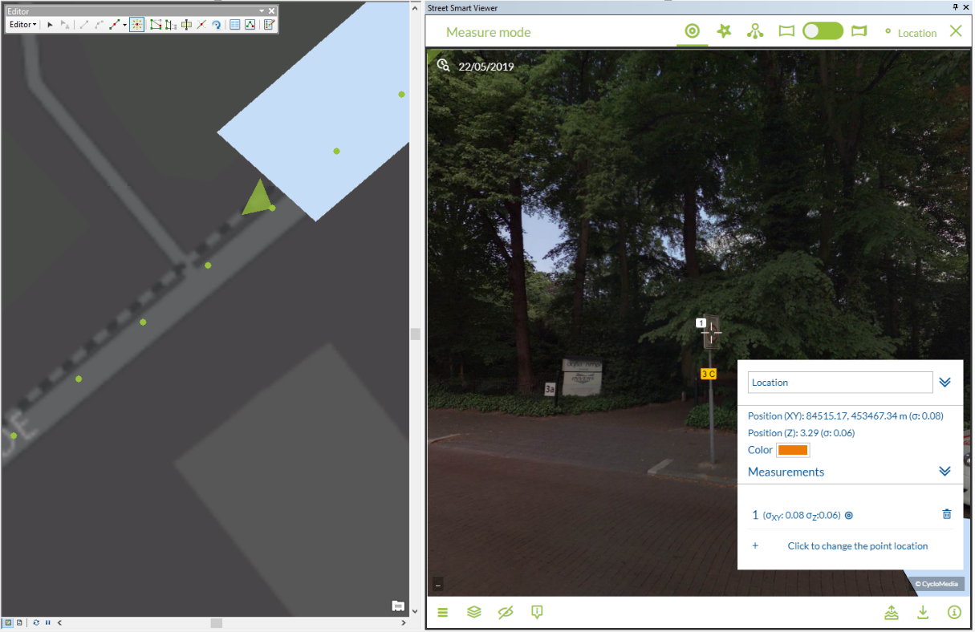

*Point measurement (with Measure Smart).*

1. The *Measurement Information* window will now show information about the measurement.
2. If you are finished with your measurements, save the edits to the vector layer in the *Editor* toolbar in ArcMap.

### Measure Smart measurement – line / surface measurement

1. Add a line or a polygon vector data layer to the map to store the measurement(s).
2. Open a Cyclorama in which the object to be measured is clearly visible.
3. Right-click on the vector layer and select: *Edit Features* ► *Start Editing* to start editing mode in ArcMap.
4. Select the line or polygon layer in the *Create Features* window to start a line or a surface measurement.
5. Enable Measure Smart measurements in the *Street Smart for ArcMap* window.
6. Select the first point you want to measure in the Cyclorama.

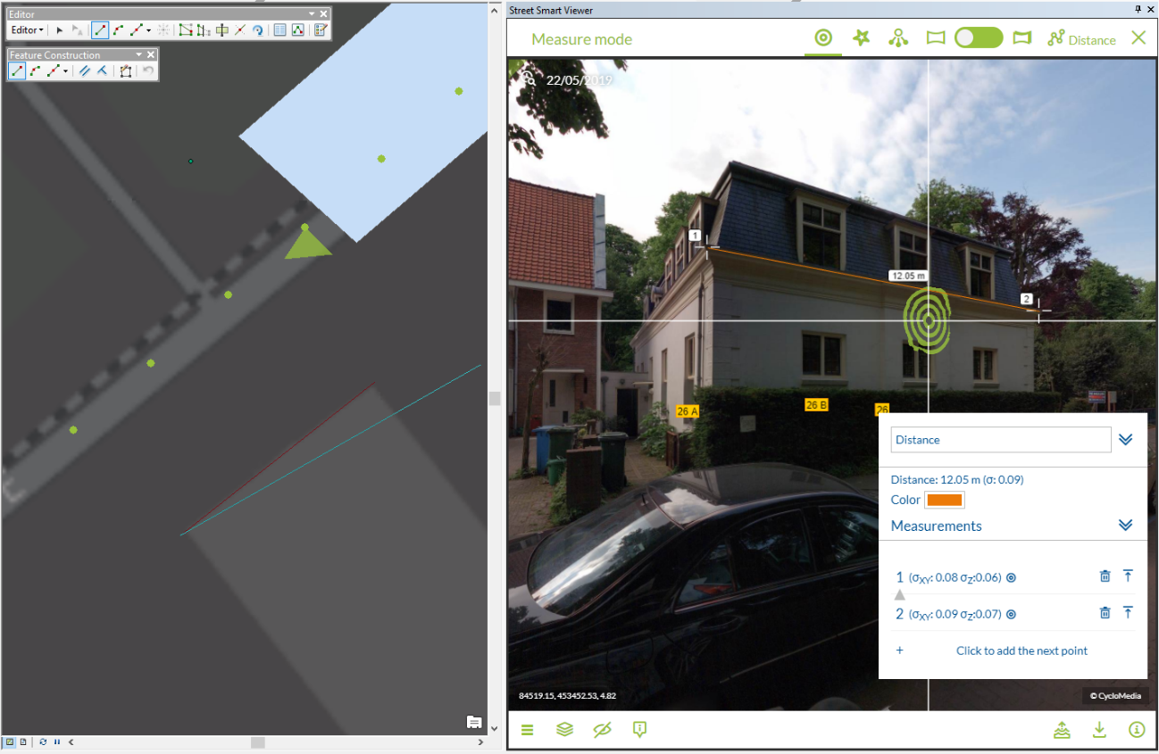

*Line or polygon measurement after adding the first point.*

1. The *Measurement Information Panel* will now show information about the measurement.
2. To add more measurement points, close the current point and add subsequent points by repeating steps 6, and 7.
3. Click on the *Finish Sketch* button on the *Feature Construction* toolbar to close the measurement.

If you are finished with your measurements, save the edits to the vector layer in the *Editor* toolbar in ArcMap.

### Forward Intersection measurement – point measurement

1. Add a point vector data layer to the map to store the measurement(s).
2. Open two or more Cycloramas in which the object to measure is clearly visible.
3. Right-click on the point vector layer and select: *Edit Features* ► *Start Editing* to start editing mode in ArcMap.

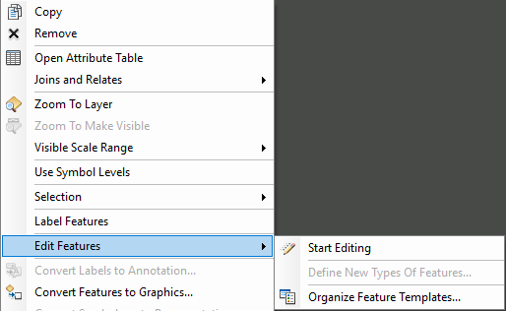

*Start editing mode in the newly added vector layer.*

1. Select the point layer in the *Create Features* window to start a point measurement.

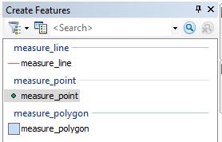

*The Create Features window with several vector layers.*

1. For Forward Intersection measurements, enable Forward Intersection measurements in the *Street Smart for ArcMap* window.  
   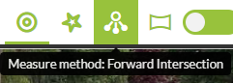

*If necessary, enable Forward Intersection measurements.*

1. Select the point you want to measure in the first Cyclorama. 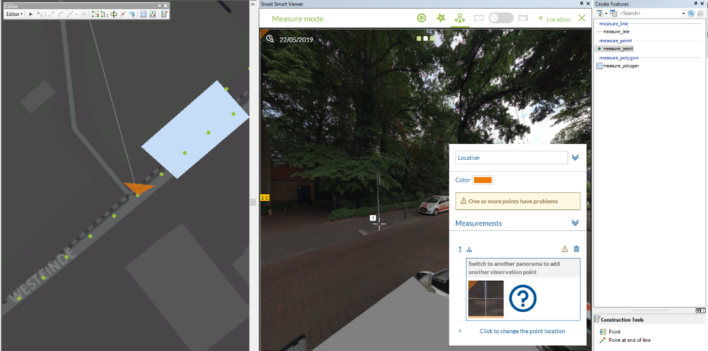
2. Select the same point in another Cyclorama.  
   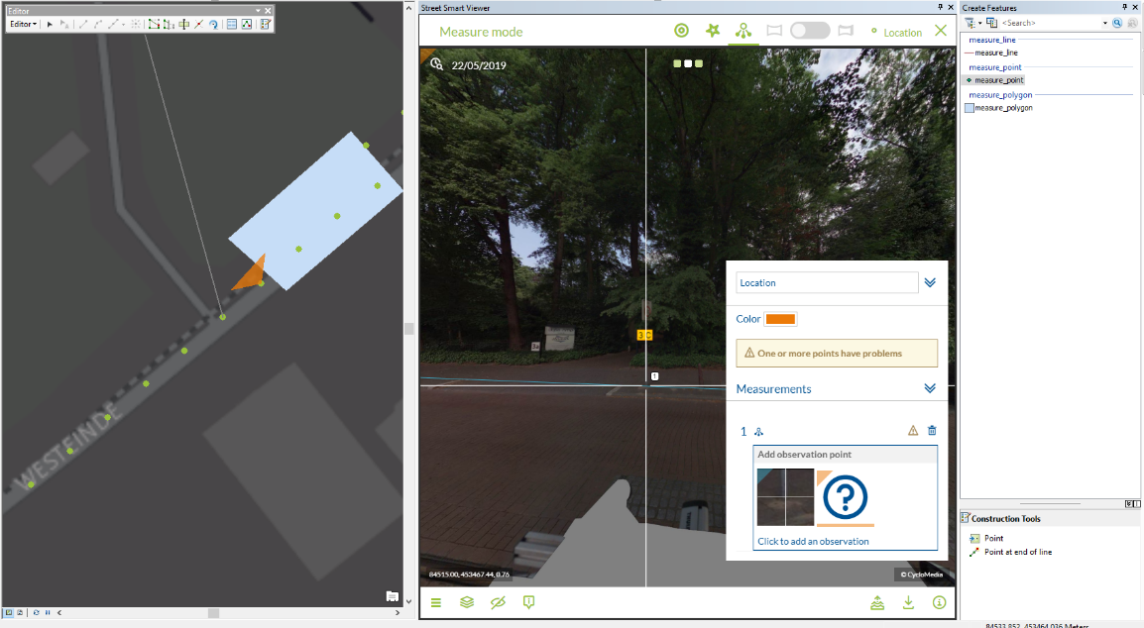

*Performing a point measurement (without Smart Click).*

1. If you are finished with your measurements, save the edits to the vector layer in the *Editor* toolbar in ArcMap, as shown in the figure below.   
     
   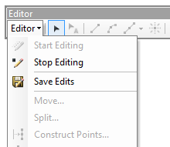

*Editor toolbar in ArcMap to save edits and to start and stop editing.*

### Forward Intersection measurement – line / surface measurement

1. Add a line or a polygon vector data layer to the map to store the measurement(s).
2. Open a Cyclorama in which the object to measure is clearly visible.
3. For Forward Intersection measurements, enable Forward Intersection measurements in the *Street Smart for ArcMap* window.



1. Right-click on the vector layer and select: *Edit Features* ► *Start Editing* to start editing mode in ArcMap.
2. Select the line or polygon layer in the *Create Features* window to start a line or a surface measurement.
3. Select the first point you want to measure in the first Cyclorama.
4. Then select the second and subsequent points you want to measure, until you have selected all the points you want to measure in the first Cyclorama.   
   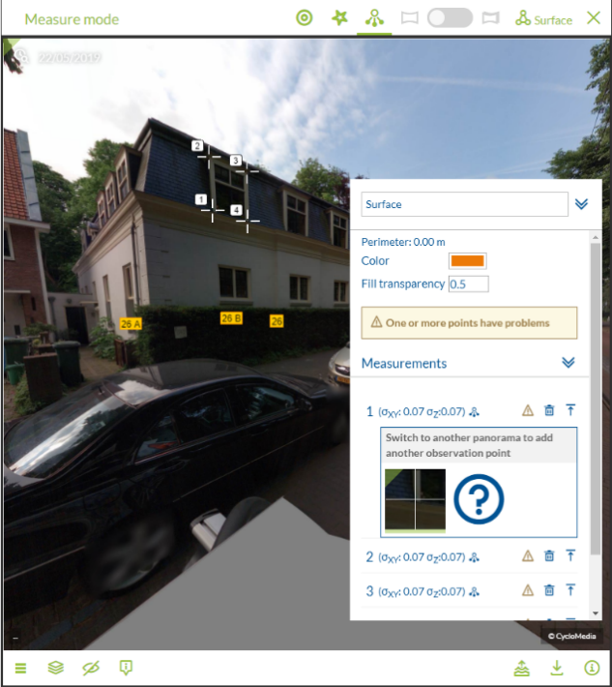

*Select all the points in the first Cyclorama step by step.*

1. Repeat the selection of points in the other Cyclorama(s) and make sure you select them in the same order as with the first Cyclorama.
2. The measurement is now complete. If you want to edit some measurement points you can add or remove observation points. Move through the measurement points by clicking on the number.
3. Click on the *Finish Sketch* button on the *Feature Construction* toolbar to close the measurement.  
   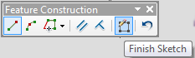

*Use Finish Sketch on the Feature Construction toolbar to close the measurement.*

1. If you are finished with your measurements, save the edits to the vector layer in the *Editor* Toolbar in ArcMap.  
     
   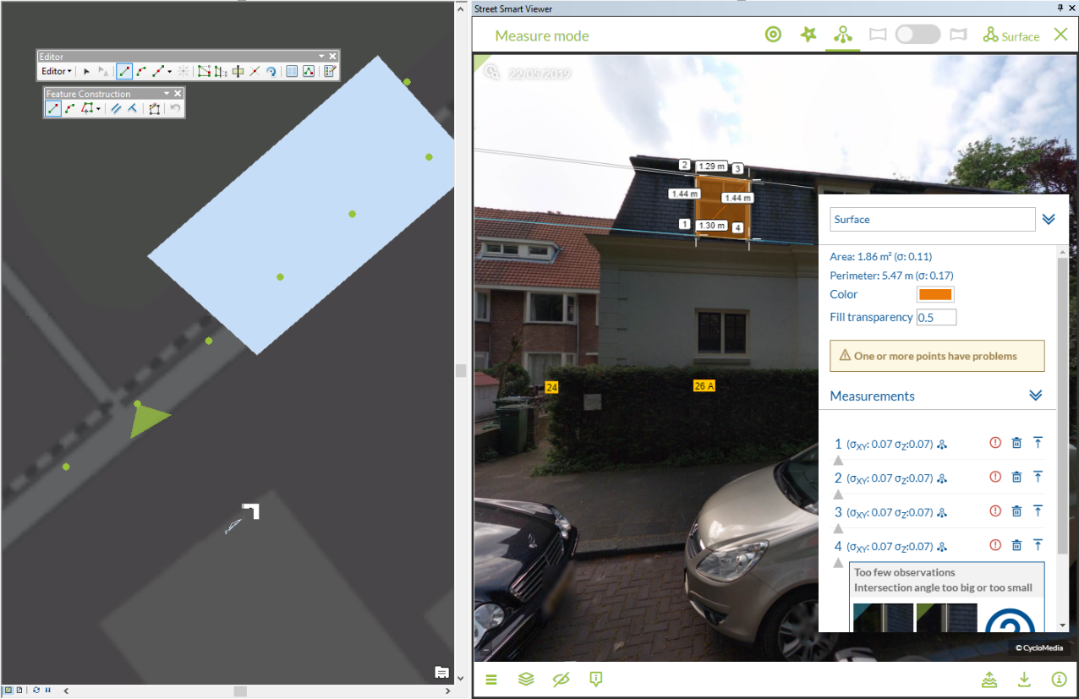

*After selecting the points in the second Cyclorama, the measurement is complete.*

### Smart Click measurement – point measurement

1. Add a point vector data layer to the map to store the measurement(s).
2. Open a Cyclorama in which the object to be measured is clearly visible.
3. Enable Smart Click measurements in the *Street Smart for ArcMap* window.  
     
   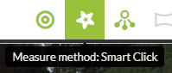

*Enable Smart Click measurements.*

1. Right-click on the vector layer and select: *Edit Features* ► *Start Editing* to start editing mode in ArcMap.
2. Select the point vector layer in the *Create Features* window to start a point measurement.
3. Select the point you want to measure in the Cyclorama.

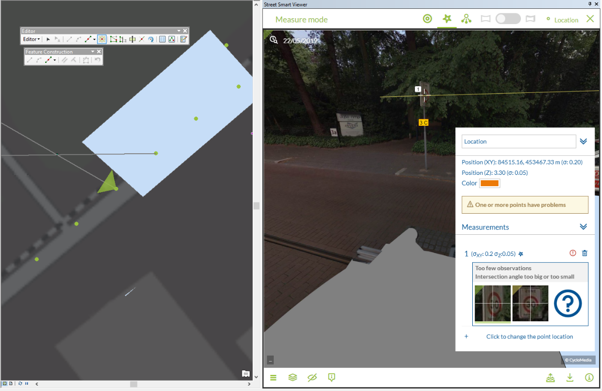

*Point measurement (with Smart Click).*

1. The *Measurement Information* window will now show information about the measurement.
2. You can check the other Cycloramas in which Smart Click found the object by clicking the point line and by clicking on the observation image. You can also add or remove observation points. If you want to add more observation points, open a new Cyclorama and select the point you want to measure.
3. If you are finished with your measurements, save the edits to the vector layer in the *Editor* toolbar in ArcMap.

### Smart Click measurement – line / surface measurement

1. Add a line or a polygon vector data layer to the map to store the measurement(s).
2. Open a Cyclorama in which the object to be measured is clearly visible.
3. Enable Smart Click measurements in the *Street Smart for ArcMap* window.
4. Right-click on the vector layer and select: *Edit Features* ► *Start Editing* to start editing mode in ArcMap.
5. Select the line or polygon layer in the *Create Features* window to start a line or a surface measurement.
6. Select the first point you want to measure in the Cyclorama.

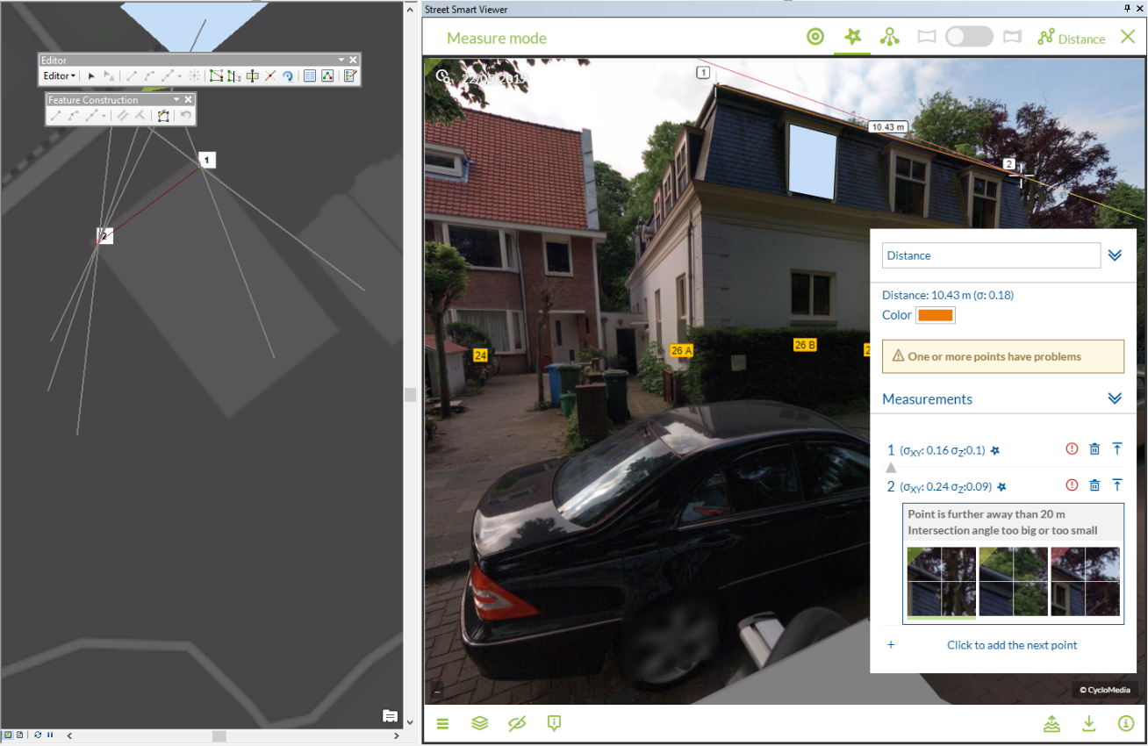

*Line or polygon measurement after adding the first point.*

1. The *Measurement Information Panel* will now show information about the measurement.
2. If you want to edit or check some observation points, click the point number first.
3. You can check the other Cycloramas in which Smart Click found the object by clicking the point line and by clicking on the observation image. You can also add or remove observation points. If you want to add more observation points, open a new Cyclorama and select the point you want to measure.
4. To add more measurement points, close the current point and add subsequent points by repeating steps 6, 7, 8 and 9. It is recommended to check all Smart Click measurement points.
5. Click on the *Finish Sketch* button on the *Feature Construction* toolbar to close the measurement.
6. If you are finished with your measurements, save the edits to the vector layer in the *Editor* toolbar in ArcMap.

### How to import a measurement in a Cyclorama

1. Select the *Edit Tool* in the *Editor* toolbar.
2. Select a feature on the map to place the measurement back in the Cyclorama.  
     
   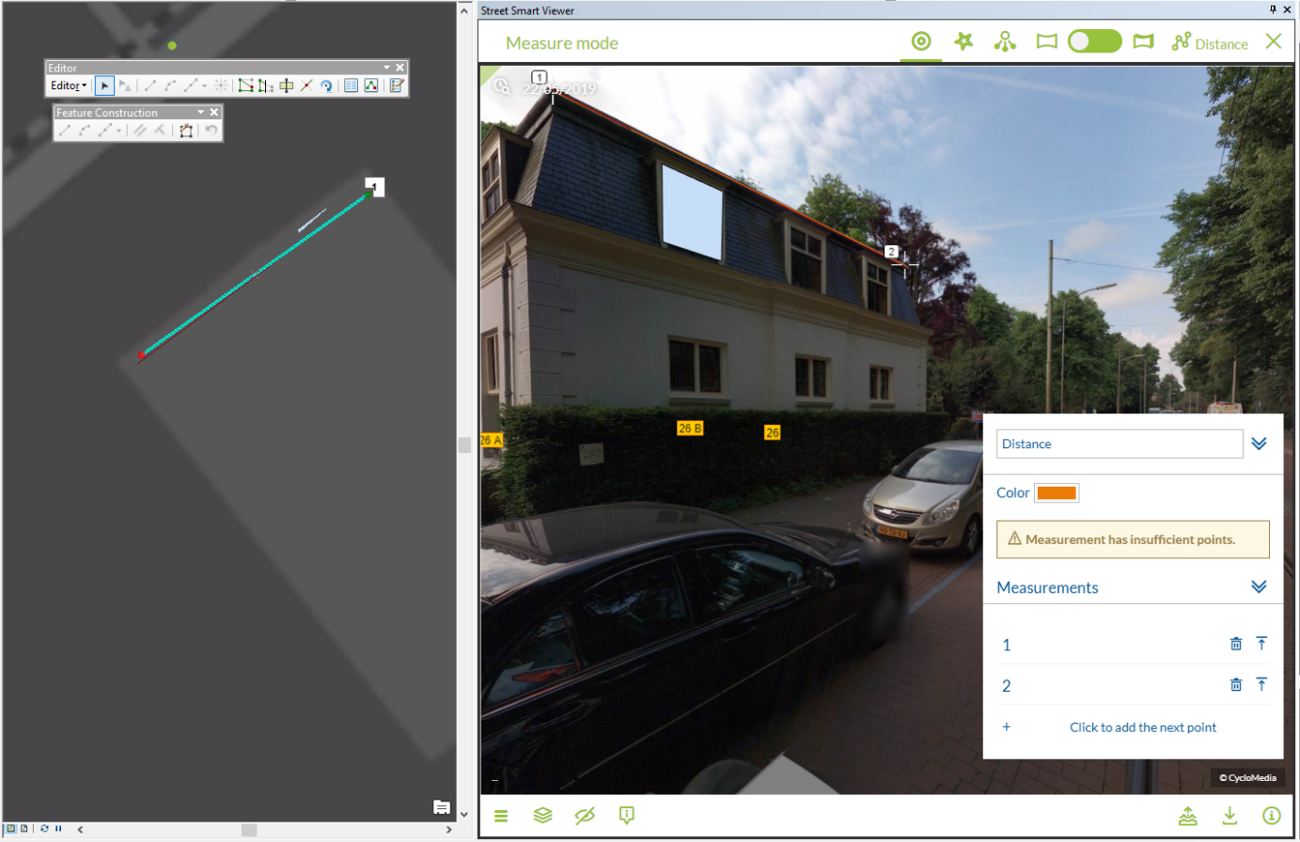

*Edit Tool in the Editor toolbar and measurement shown in Cyclorama*

1. Right-click on a (selected) feature and select *Edit Vertices* in the context menu to edit the measurement in the Cyclorama.  
     
   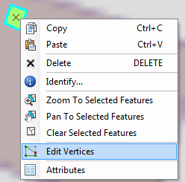

*Select Edit Vertices to edit a measurement in a Cyclorama.*

1. It is now possible to edit the measurement in the Cyclorama or on the map.
2. If you want to edit a measurement point in the Cyclorama, select that point in the map.
3. Use the *Sketch Properties* button in the *Editor* toolbar to view the values of the measurement points.   
     
   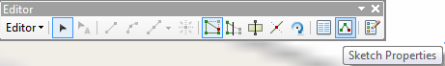

*Sketch Properties in the Editor toolbar.*

1. You can change the measurement values by selecting a point. The M value is the reference to the number of that point in the cyclorama.

*Edit Sketch Properties.*

### How to do a measurement without saving in a layer

1. Click on the 'start measurement' button. See the figure below.

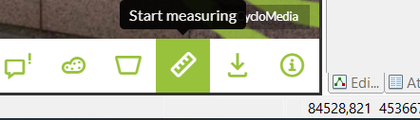

*Toolbar with the selected 'start measurement' button.*

1. Select the type of measurement you want to take. See the figure below

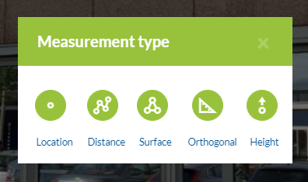

*The measurement type selection box..*

1. Now it is possible to measure. The measurement is not stored in a layer.

## Cyclorama search functionality

1. To start the cyclorama search functionality, click on the cyclorama search button in the Street Smart toolbar.

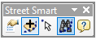

*Cyclorama search button*

1. You will now see the cyclorama search window.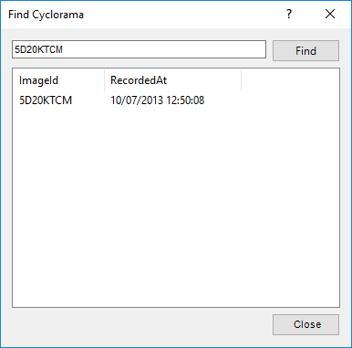

*Find Cyclorama window*

1. Enter an imageId and press the ‘Find’ button.
2. After a few seconds you will get the results
3. Double-click a result and you go to the cyclorama.